Your Social Prescribers Partnership Team  Who are we?  We are a friendly, compassionate and non-judgemental team here to help support your patients with non-medical issues. We are available to listen and connect people to the right service and community groups.      Many patients visit their GP because they feel isolated or lonely. Some are stressed by work, money, childcare, or housing problems. Sometimes it’s the stress of managing a long-term health condition that brings them to the Surgery.  What can we help with?  Social Prescribers work with individuals to help them access the support that may assist with their non-medical concerns. Some of these support services are illustrated below: |   Promotional messaging  to patients  Social Prescribers can connect you to community groups or other services for practical and emotional support  Social Prescribers are friendly, non-medical link workers, who give you time to focus on what matters to you  Social Prescribers have a long track record in helping people improve their health and wellbeing  Social Practitioners  Steve Carr  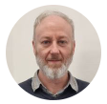  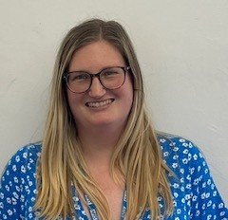  Ella Locker  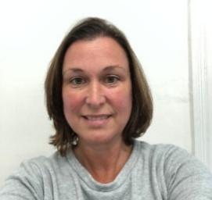  Kerry Broadmore
  - Advocacy  - Bereavement Support  - Carers and their caring role  - Confidence building/low self-esteem  - Debt  - Employment and Volunteering  - Food banks, Gas and electricity  - Healthy lifestyles support  - Housing support  FOR A REFERRAL TO THE SOCIAL PRESCRIBING TEAM PLEASE SPEAK TO A CLINICIAN OR THE RECEPTION TEAM. | - Managing long term health conditions  - Mental Health, Anxiety and Wellbeing support  - Mobility and transport  - Social Activities  - Social Isolation  - Supporting attendance at groups  - Loneliness/befriending support    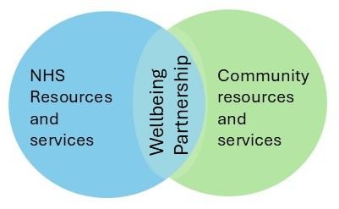  - Literacy  The Social Prescribers work in partnership with Age UK North Yorkshire Coast and Moors.


